

**This is a how-to guide for installing all fonts that we use for LiC comms and documents.**

**Fonts we use:**

Headings: Walter Turncoat

Body: Mont light

**All zipped files for fonts have been included on the memory stick you received at the management conference in 2022

**How to Install Fonts on a PC**

**1) Shut down any program you want to use the font in.**

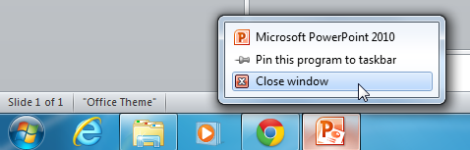

**2) Download the font to your computer and open the zip files if necessary.**

It may have a .zip, .otf, or .ttf file extension. If it’s a .zip file, you’ll need to extract the compressed files by double-clicking on the file - your computer will automatically unzip the file and open the folder inside.

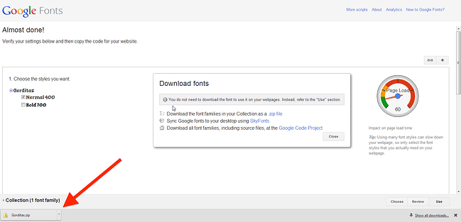

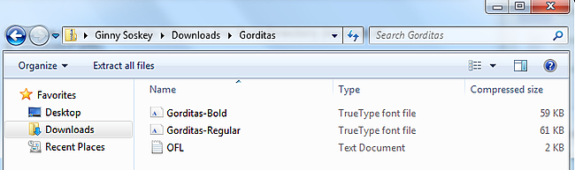

**3) Right-click on each font you’d like to add, then choose "Open."**

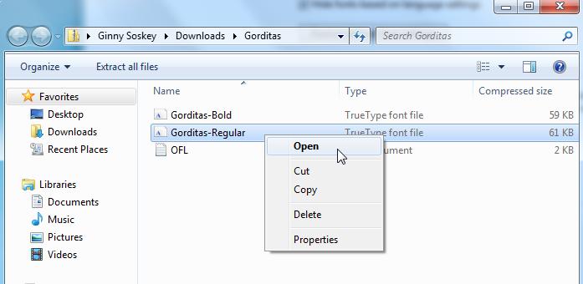

**4) Once open, click “Install” to add the font to your computer.**

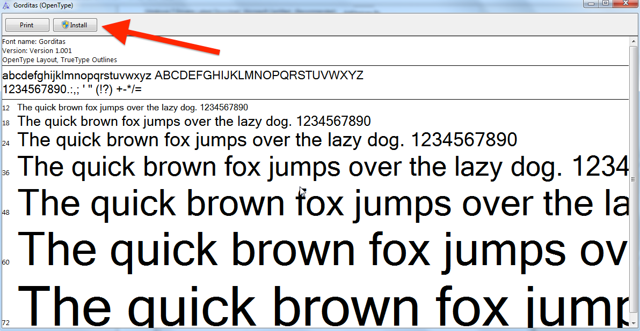

**5) Open up the program you’d like to use and the font will be there.**

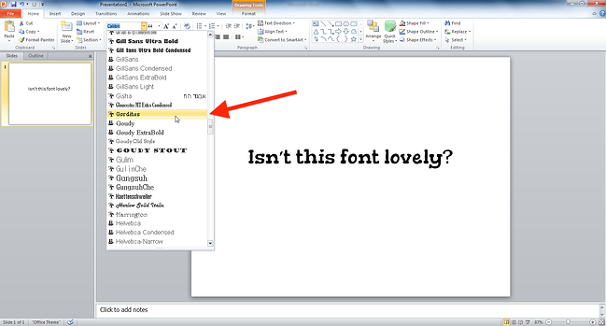

You’re ready to use the LiC fonts in any program on your computer.

**How to Install Fonts on a Mac**

**1) Shut down any program you want to use the font in.**

Make sure you're completely shutting down each program, not just hitting the exit button.

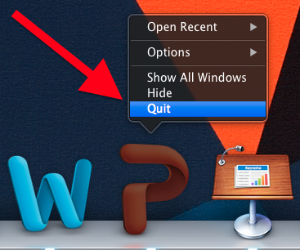

**2) Download the font to your computer and extract files if necessary.**

Font files may have a .zip, .otf, or .ttf file extension. If it’s a .zip file, you’ll need to extract the compressed files by double-clicking on the file -- your Archive Utility will automatically unzip the file.

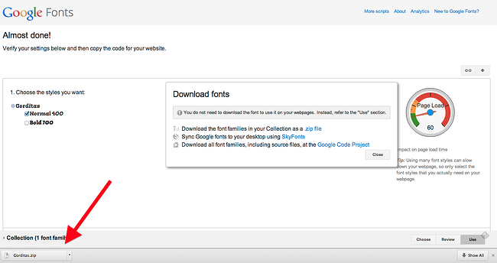

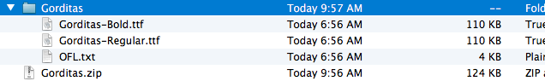

**3) Open Font Book.**

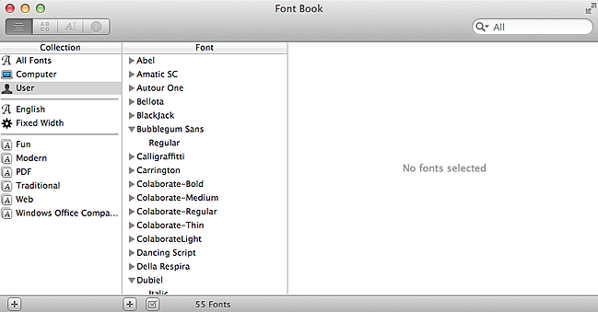

**4) Select the fonts in your Downloads folder you want to install and drag them to Font Book.**

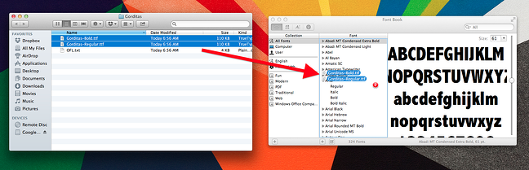

**5) Open up the program you’d like to use and the font will be there.**



